FAULT-TOLERANT ALGORITHM DESIGN FOR
SENSOR FUSION IN AUTONOMOUS VEHICLE SYSTEMS
[MARWADI UNIIVERSITY]
[Faculty of Engineering and Technology]
Department of Computer Science and Engineering

A Research Report
Submitted in partial fulfilment of the requirements for the degree of Bachelor of Technology (B.Tech) in
Computer Science and Engineering
By

[Velagala Somya sri ] – [92400118621]
Under the Guidance of
[Prof. ABHISHEK CHAUHAN]

SEPTEMBER-2026

Abstract
An autonomous vehicle builds its picture of the road from several sensors that partly measure the same thing. When one of them fails quietly, by freezing on an old value or by slowly drifting away from the truth, an ordinary weighted average carries that error straight into the estimate. This report treats the situation as an algorithm-design problem: given n redundant readings of which up to f may be wrong, how should they be combined so that the result stays usable, and what does that protection cost in running time?
The method studied here converts each reading into a confidence interval, finds the stretch of the number line covered by the largest number of intervals with a sort-and-sweep pass in the style of Marzullo, drops every sensor whose interval does not touch that stretch, and averages the remaining readings with inversevariance weights. One fusion cycle costs O(n log n) time and O(n) space. A simulated lead-vehicle range experiment with five sensors and five injected fault types (stuck, offset, drift, noise burst and spike) was used to compare the method with the simple mean, the weighted mean, the median and a median-gated weighted mean. With one or two faulty sensors the proposed routine gave the lowest RMSE of the five methods and flagged faulty sensors with a precision above 0.99. With three faulty sensors, which is beyond what five sensors can tolerate by design, every method degraded. All reported numbers come from simulated data and should be read as a demonstration of the method and the evaluation procedure, not as a measurement of any real vehicle.
Keywords – Sensor Fusion, Fault Tolerance, Autonomous Vehicles, Interval Agreement, Marzullo Algorithm,
Inverse-Variance Weighting, Redundancy, Fault Detection

I. Introduction
A self-driving car does not rely on one instrument. Lidar gives accurate distances but suffers in heavy rain and dust, radar copes with weather but can be fooled by metal structures and multipath reflections, and cameras give rich detail but are sensitive to glare and darkness [10]. Each sensor also has its own hardware failure modes. The usual answer is redundancy: several sensors observe overlapping parts of the scene, and a fusion stage merges their readings into one estimate that the planning and control software can use [1],
[2].
Fusion is only as safe as its assumptions. The common textbook form, a weighted average in which precise sensors count for more, is optimal when every input is healthy and its noise level is known [6]. It has no defence against an input that is simply wrong. A radar that locks onto a guard rail, or a camera driver that keeps re-sending the last frame, contributes a confident but false number, and because the weight is based on the sensor’s nominal accuracy, the false number is often trusted the most.
From an algorithmic point of view the question can be stated cleanly. There are n readings of one unknown quantity, each with a known uncertainty. Some of them, at most f, may be arbitrarily wrong at any moment and nothing announces which ones. The algorithm has to return an estimate that remains close to the truth, ideally point out the suspicious sensors, and finish within the time budget of a control cycle, which is typically tens of milliseconds. Distributed computing has studied a similar situation under the name of Byzantine faults [7]. Marzullo adapted the idea to sensors that report continuous values with error bounds [8], and Brooks and Iyengar later combined interval agreement with averaging [9]. The present report builds on that line of work.
To keep the analysis readable the study is limited to a single scalar, the distance to the vehicle ahead, measured by five sensors, with one fusion decision per time step. Production perception stacks track many objects in several dimensions and use filters that carry information across time. Those extensions are left for future work, but the scalar case already shows every ingredient of the design: a fault model, a detection rule, a fusion rule, a complexity analysis and an evaluation procedure. A deliberately classical algorithm was chosen over a learned fusion network because its behaviour can be reasoned about and bounded without a training set, which matters when the output feeds a safety-related function.
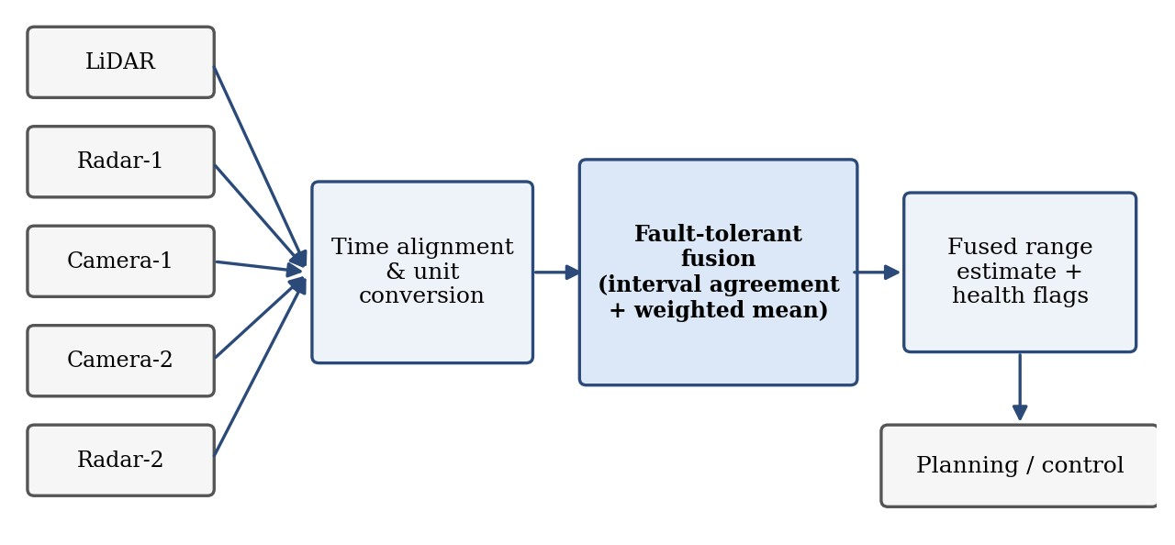
Figure 1. Position of the fusion stage between redundant sensors and the planning module.

A. Problem Statement
Given n sensors that report readings z_{i} of an unknown scalar x, with known noise standard deviations σ_{i}, and given that at most f < n/2 of the sensors are faulty at any time in ways that are not known in advance, compute an estimate x ̂ of x and a set of flagged sensors such that (a) x̂ remains close to x whenever the fault assumption holds, (b) flagged sensors are very likely the faulty ones, and (c) the computation is cheap enough to run in every sensing cycle.

B. Research Objectives
- To define a sensor model and a fault model that cover the failures most often discussed for vehicle perception: stuck output, constant offset, slow drift, noise bursts and sporadic spikes.
- To design a fusion algorithm that tolerates up to f faulty sensors out of n using interval agreement followed by weighted averaging.
- To prove the basic correctness property of the algorithm and to bound the influence that an undetected faulty sensor can have.
- To analyse the time and space complexity of the algorithm.
- To compare the algorithm with four simpler fusion rules under Monte Carlo fault injection.
- To study the effect of the interval width factor k on detection quality.
- To discuss the limitations of the approach, including correlated failures and the case in which the fault bound is exceeded.

C. Scope of the Research
The study covers redundant measurement of one scalar quantity with independent sensor noise and synchronised samples. Object detection, data association, tracking, localisation, multi-dimensional state estimation and the physical details of individual sensors lie outside the main scope. The experiments are simulations, so the report demonstrates and compares algorithms; it does not certify a design for use on a vehicle, and it makes no claim of compliance with functional-safety standards such as ISO 26262 [12].

II. Literature Review
Work relevant to this problem comes from three directions: multisensor data fusion, fault detection in control systems, and fault-tolerant distributed computing. The sections below follow that order and end with the gap that motivates this report.

A. Multisensor Data Fusion
Hall and Llinas give a widely cited introduction to multisensor data fusion and explain why combining sources can give better accuracy and more dependable inference than any single source [1]. Khaleghi et al. later reviewed the field and organised its difficulties around the quality of the data itself, listing imperfect measurements, outliers and spurious data, conflicting data and correlation among sources among the main challenges [2]. For vehicles specifically, Van Brummelen et al. survey perception sensors and point out that every sensing technology has conditions in which it degrades, which is the practical reason for redundancy [10].

B. Faults, Errors and Failures
Avižienis et al. separate a fault (the cause), an error (the wrong internal state) and a failure (the service delivered is wrong), and describe fault tolerance as preventing faults from turning into failures by means such as error detection and redundancy [3]. This vocabulary is useful here. A drifting sensor is a fault; a fused estimate that is off by several metres is an error; a planner braking for a vehicle that is not there would be a failure. The algorithm studied in this report acts at the stage where the error could still be stopped.

C. Model-Based Detection and Filtering
Isermann’s survey describes model-based fault detection, in which a mathematical model predicts what a sensor should read and the difference between the prediction and the measurement, the residual, is tested against a threshold [4]. The Kalman filter [5], [6] belongs to the same family: its innovation sequence can be used to reject measurements that disagree with the prediction. These methods are powerful when a good dynamic model exists, and they use information from past time steps. Their weakness is that a slowly growing fault can be absorbed by the filter state before the residual becomes large, and that they depend on the model being right.

D. Agreement-Based Methods
Lamport, Shostak and Pease posed the Byzantine generals problem, in which some participants may behave arbitrarily and the rest must still reach agreement [7]. Marzullo transferred the idea to continuous-valued sensors [8]. Each sensor supplies an interval that should contain the true value, and the algorithm returns the region consistent with at least n − f of the n intervals, which can be found by sorting the interval endpoints. If the correct sensors really do bracket the true value, the true value is guaranteed to lie in that region. Brooks and Iyengar proposed a hybrid that keeps the interval-overlap test but also produces a point estimate by weighted averaging [9]. The method evaluated in this report is closely related to both: it uses Marzullo’s sweep to decide which sensors to trust and inverse-variance weighting, rather than interval midpoints, to compute the final number. E. Comparative Review
Approach | Main idea | Advantage | Limitation
Simple mean | Average all readings | Trivial to implement | One bad reading shifts the result; ignores sensor accuracy
Weighted mean (IVW) | Weight by 1/σ² | Minimum variance when all sensors are healthy [6] | Trusts precise sensors most, even when they fail
Approach | Main idea | Advantage | Limitation
Median / voting | Take the middle reading | Ignores up to ⌊(n−1)/2⌋ bad values | Ignores differences in accuracy; no explicit fault flag
Residual testing / Kalman gating | Reject readings far from the prediction | Uses the past; mature theory [4], [6] | Needs a model; slow drift can be absorbed
Interval agreement (Marzullo) | Largest overlap of intervals | Guaranteed containment when ≤ f faults [8] | Returns a region, not a refined point estimate
Brooks–Iyengar hybrid | Overlap test plus weighted average | Gives both accuracy and precision [9] | Weights depend on overlap counts, not noise levels

F. Research Gap
The individual ingredients of this study are not new. What is often missing in teaching material and small projects is one worked pipeline in which the fault model, the detection rule, the fusion rule, the complexity analysis and the evaluation all appear together and are tested against strong simple baselines, in particular the median, which already tolerates a minority of faults. This report fills that gap in a modest way. It does not claim that the proposed routine is a new fusion principle; it asks how much the combination of interval agreement and inverse-variance weighting adds over the median, and where the combination stops working.

III. Research Methodology
The study follows a simulation-based comparative method. A true range signal is generated, five sensors measure it with their own noise levels, faults are injected into some of the sensors for part of each run, every fusion method processes the same readings, and the estimates are compared with the known truth. Because the truth is known exactly, errors can be measured directly, which is not possible with real driving logs. A. Research Design
Stage | Description
1. Signal generation | Create the true range x(t) of the lead vehicle for 600 steps of 0.1 s.
2. Sensor model | Add independent Gaussian noise with a different σ for each of the five sensors.
3. Fault injection | Corrupt a randomly chosen subset of sensors for a window of 120–259 steps.
4. Interval construction | Form [z − kσ, z + kσ] for every sensor.
5. Agreement sweep | Sort end-points, count overlaps, select the best region.
6. Flagging and fusion | Flag sensors that miss the region; fuse the rest by inverse-variance weighting.
7. Evaluation | Compute RMSE, unsafe-estimate rate, detection statistics and run time.

B. Sensor and Signal Model
The true distance to the lead vehicle is x(t) = 40 + 10 sin(2πt/300) + 0.01t metres, which makes the gap swing slowly between roughly 30 m and 52 m. The five sensors are named after typical automotive devices, although the study does not attempt to model any particular product. Their noise standard deviations are 0.10 m for the lidar, 0.25 m and 0.20 m for the two radars, and 0.50 m and 0.40 m for the two cameras, so there is a clear difference in accuracy for the weighting step to exploit.

C. Fault Model
Five fault types are injected. Each one lasts for a window of 120 to 259 steps that starts at a random time.
- Stuck: the output freezes at the value it had when the fault began.
- Offset: a constant error of between 2 m and 5 m, positive or negative, is added.
- Drift: an error that grows linearly from zero to between 3 m and 6 m over the window.
- Burst: the noise standard deviation becomes ten times its normal value.
- Spike: at each step with probability 0.3 an outlier of between 5 m and 15 m is added.
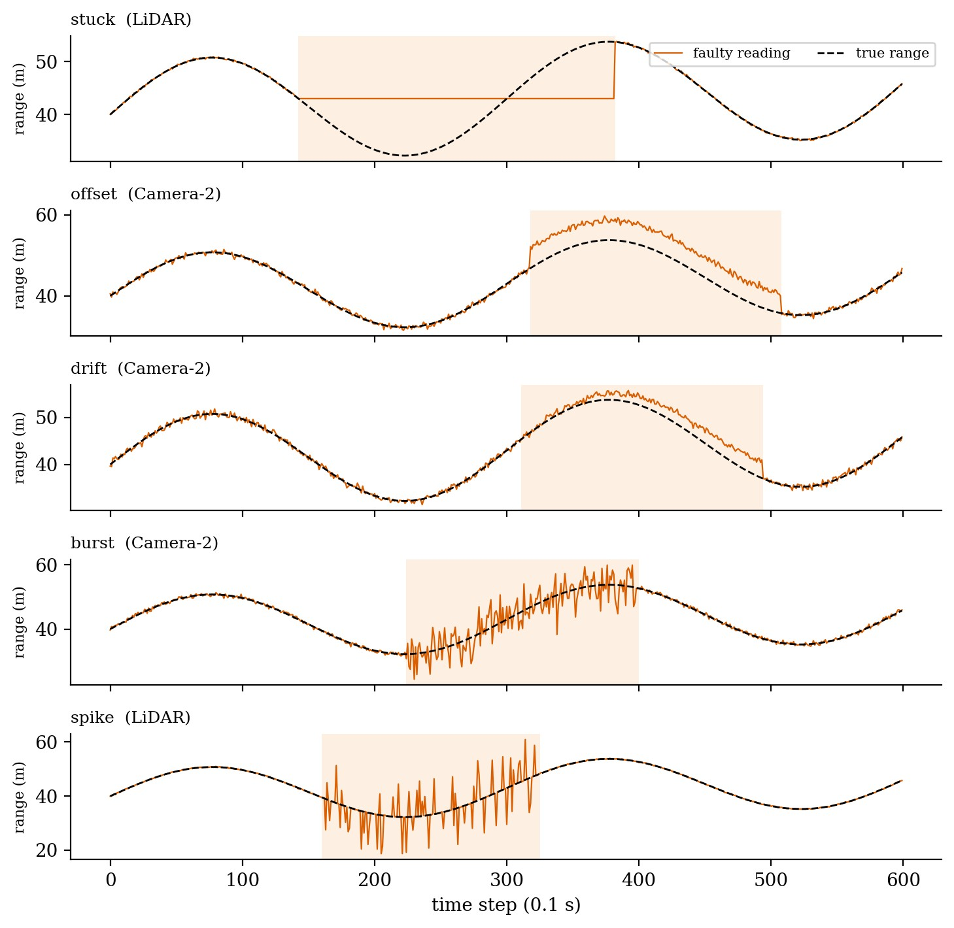
Figure 2. The five injected fault types on a single sensor. The shaded band marks the fault window.

D. Assumptions
- Noise of healthy sensors is Gaussian, independent between sensors and has a known standard deviation.
- Samples from all sensors refer to the same instant, so time alignment has already been done.
- At most f < n/2 sensors are faulty at one time. For n = 5 the design value is f = 2.
- A healthy sensor’s interval contains the true value. With k = 3 this holds for about 99.7 % of healthy readings; the remaining 0.3 % are an accepted source of occasional false flags.

IV. Mathematical Foundation
A. Sensor Model
A healthy sensor i reports

z_{i} = x + e_{i}, e_{i} ~ N(0, σ_{i}²)
where x is the true value. A faulty sensor reports an arbitrary value. The algorithm is told z_{i} and σ_{i} but not which sensors are faulty.

B. Inverse-Variance Weighting
If every sensor were healthy, the minimum-variance unbiased linear combination of the readings would be the weighted mean with weights w_{i} = 1/σ_{i}² [6]:

x̂ = Σ w_{i} z_{i} / Σ w_{i}
The variance of this estimate is 1 / Σ w_{i}, smaller than that of any single sensor. For the five sensors used here it is about 0.081 m in standard deviation. The same formula, restricted to a subset of sensors, is used as the final step of the proposed algorithm.
C. Intervals and the Agreement Count
For a width factor k, sensor i defines the interval
I_{i} = [ z_{i} − kσ_{i} , z_{i} + kσ_{i} ]
and the agreement count at a point y is the number of intervals that contain it:

c(y) = | { i : y ∈ I_{i} } |
Let c* be the maximum of c(y). The agreement region R is the set of points where c(y) = c*; if several separate regions share that maximum, the one nearest to the median of the readings is used. The consistent set is S = { i : I_{i} ∩ R ≠ ∅ }, and the sensors outside S are flagged. The fused estimate is
x̂ = Σi∈S wi zi / Σi∈S wi

D. Correctness and Bounded Influence
Proposition 1 (containment). Suppose at most f sensors are faulty and every healthy sensor’s interval contains x. Then c(x) ≥ n − f, so c* ≥ n − f and the test c* ≥ n − f succeeds. The true value lies in a region of agreement count at least n − f.
Proof. At least n − f sensors are healthy and each of their intervals contains x, so at least n − f intervals cover the point x.
The proposition does not say that the region selected by the algorithm is the one containing x. When f < n/2 it is still possible for two separate regions to reach the count n − f, for example when three intervals overlap in one place and a different three overlap in another, with one interval shared. The median-based tie-break is a heuristic for that case, not a guarantee, and this is one reason the method is evaluated experimentally as well as analysed.
Proposition 2 (bounded influence). If x ∈ R, every sensor that survives the consistency test satisfies |z_{i} − x| ≤ kσ_{i} + (hi − lo), where [lo, hi] = R, and the width hi − lo is at most 2kσ_{j} for every sensor j whose interval covers R.
Proof. Interval I_{i} touches R and has half-width kσ_{i}, so z_{i} is within kσ_{i} of some point of R; since x also lies in R, the distance to x cannot exceed kσ_{i} plus the width of R. R lies inside every interval that covers it, so its width cannot exceed the width 2kσ_{j} of any of them.
The second statement is the useful one: a faulty sensor that escapes detection can only have a reading within a small multiple of the sensor noise levels of the truth, however large its nominal fault is. A fault can hide only by being small.

E. Interpretation of Quantities
Quantity | Low value indicates | High value indicates
Agreement count c* | Sensors disagree; more than f may be faulty | Most sensors agree on a common region
Quantity | Low value indicates | High value indicates
Region width hi − lo | Tight agreement between accurate sensors | Agreement only between noisy sensors, so a coarse estimate
Number of flagged sensors | Little evidence of any fault | Several sensors inconsistent with the majority
Factor k | Narrow intervals, many false flags | Wide intervals, small faults go unnoticed

V. Proposed Fault-Tolerant Fusion Algorithm
The routine works on one time step at a time. It needs no training and no history, only the current readings and the known noise levels, so its behaviour on any input can be traced by hand.
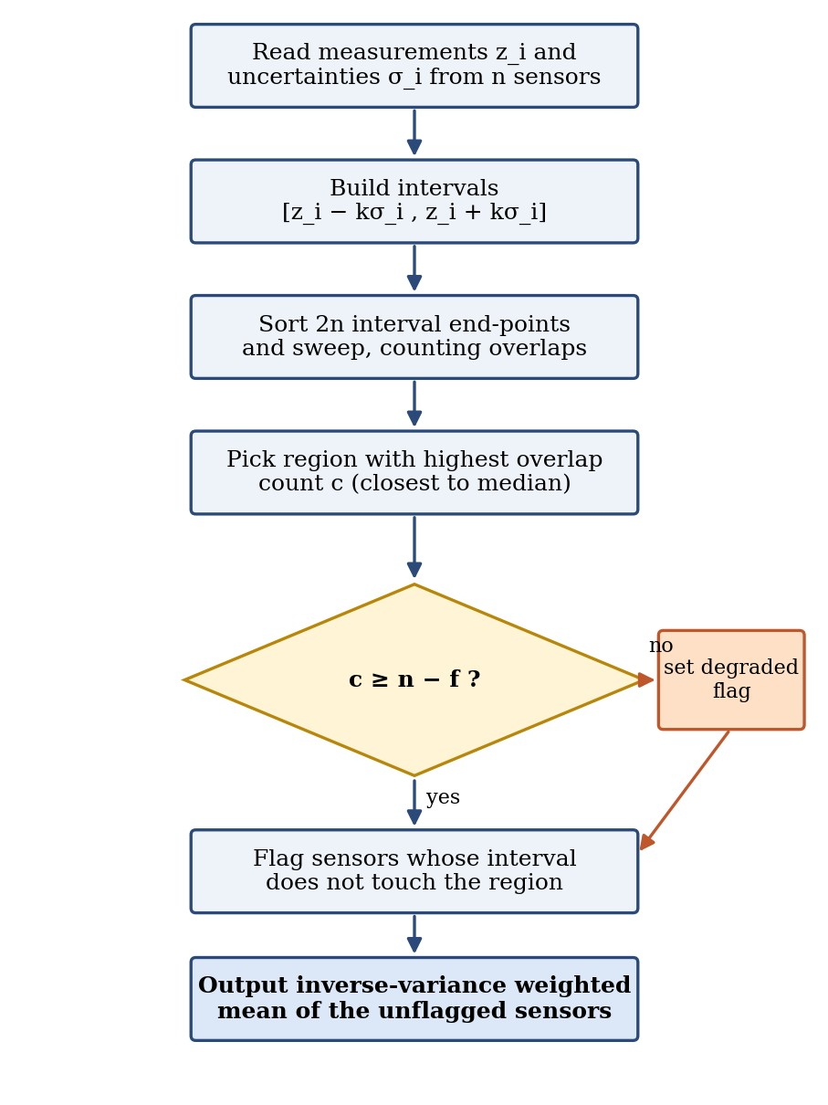
Figure 3. Flowchart of the proposed fault-tolerant fusion algorithm.

A. Algorithm Steps
- Receive readings z_{i}, noise levels σ_{i}, the fault bound f and the width factor k.
- Create the interval [z_{i} − kσ_{i}, z_{i} + kσ_{i}] for every sensor.
- Put all 2n end-points in one list and sort it, with interval starts placed before interval ends when positions tie.
- Sweep through the list, increasing a counter at each start and decreasing it at each end, and record the count for each stretch between neighbouring end-points.
- Select the stretch with the highest count; if several tie, take the one closest to the median reading.
- If the highest count is smaller than n − f, mark the result as degraded.
- Flag every sensor whose interval does not touch the selected stretch.
- Return the inverse-variance weighted mean of the unflagged sensors, the flagged set and the degraded marker.

B. Pseudocode
Algorithm: Interval-Agreement Fault-Tolerant Fusion
Input : readings z[1..n], std-devs s[1..n], fault bound f, factor k Output: estimate xhat, flagged set Fl, degraded flag

1. events <- empty list 2. for i = 1 to n:
- append (z[i] - k*s[i], START, i) to events
- append (z[i] + k*s[i], END, i) to events
- sort events by position (START before END on ties) 6. count <- 0; best <- 0; segments <- empty list
- for j = 1 to 2n - 1:
- if events[j] is START: count <- count + 1
- else: count <- count - 1
- append (count, events[j].pos, events[j+1].pos) to segments
- best <- max(best, count)
- R <- segment with count = best nearest to median(z)
- degraded <- (best < n - f)
- S <- { i : interval i intersects R }
- xhat <- sum_{i in S} z[i]/s[i]^2 / sum_{i in S} 1/s[i]^2
- return xhat, {1..n} - S, degraded

C. Worked Example
Take one time step in which the true range is 40.00 m. The lidar reads 40.05 m, Radar-1 reads 40.30 m, Camera-1 reads 39.70 m, Radar-2 reads 40.12 m, and Camera-2, which has developed an offset fault, reads
43.60 m. With k = 3 the intervals are those in Figure 4. Four of the five intervals overlap on the region [39.75, 40.35], so c* = 4, which satisfies c* ≥ n − f = 3. The Camera-2 interval, [42.40, 44.80], does not touch that region and the camera is flagged.
The four remaining sensors have weights 100, 16, 4 and 25 (for lidar, Radar-1, Camera-1 and Radar-2), which sum to 145. The weighted sum of readings is 5811.6, so the fused estimate is 5811.6 / 145 = 40.080 m. A plain weighted mean over all five sensors would have given 40.225 m, because the faulty camera still receives a weight of 6.25.
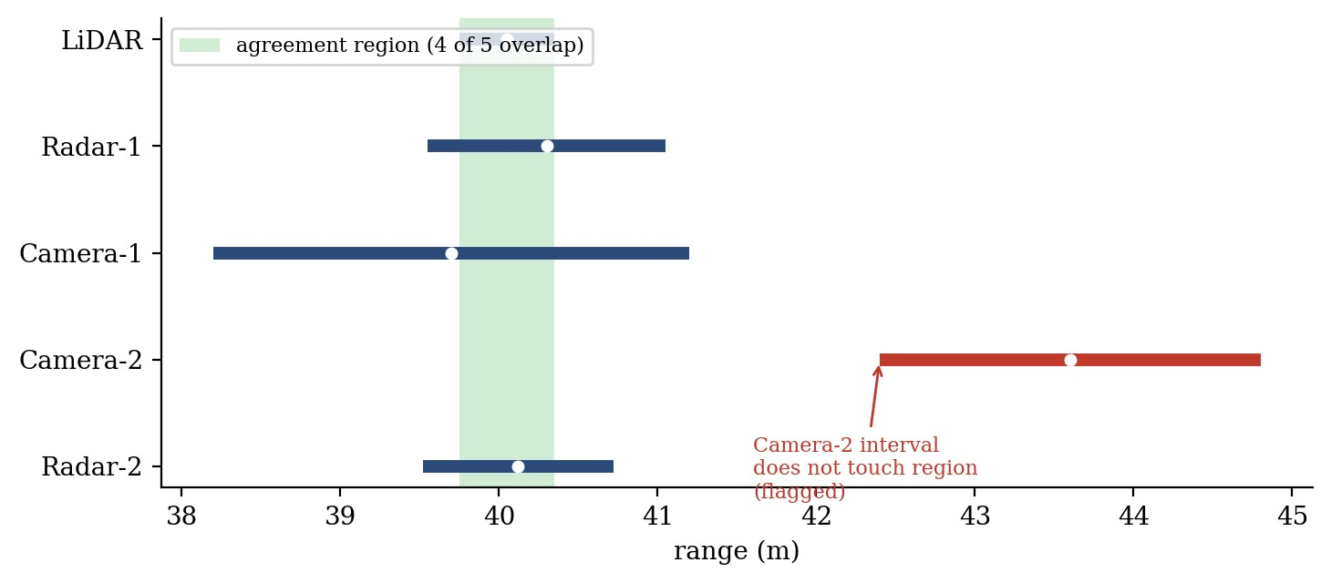
Figure 4. Worked example. Bars are the intervals z ± 3σ, circles are the readings, and the shaded band is the agreement region.

D. Complexity Analysis
Let n be the number of sensors. Building the 2n end-points takes O(n) time. Sorting them takes O(n log n) with any comparison sort [11]. The sweep visits each end-point once, O(n). Choosing the best segment needs one pass over the segments and a median of the readings, which is O(n) with a selection algorithm and O(n log n) if the readings are simply sorted. Testing each interval against the region and computing the weighted mean are O(n) each. The sorting step dominates, so one fusion cycle costs T(n) = O(n log n)
Component | Approximate complexity | Reason
Interval construction | O(n) | One pass over the sensors
Sorting end-points | O(n log n) | 2n values sorted by position
Sweep and counting | O(n) | One pass over 2n sorted events
Region selection | O(n) | Scan of segments and median of readings
Flagging | O(n) | Compare each interval with the region
Weighted mean | O(n) | One pass over the unflagged sensors
Total per cycle | O(n log n) | Dominated by the sort

For comparison, the median can be found in expected O(n) time with a selection algorithm and the weighted mean in O(n), so the proposed method is asymptotically a little more expensive than either. In exchange it produces the flagged set, which neither of the others does. For the five sensors used here the difference is irrelevant in practice; the scaling matters if a system fuses hundreds or thousands of redundant measurements per cycle, and Section VI reports how the implementation behaves in that range.

E. Space Complexity
The event list has 2n entries and the segment list at most 2n − 1, so the working memory is O(n), in addition to the n readings and noise levels that are the input. Nothing is carried from one step to the next. F. Implementation Environment
Component | Configuration
Programming language | Python 3 (the sweep is written in plain Python)
Numerical library | NumPy for array operations, the median and random numbers
Plotting | Matplotlib
Random numbers | NumPy default_rng with fixed seeds (listed in Appendix D)
Execution | Single thread; absolute timings depend on the machine

VI. Experimental Validation
All experiments use simulated data generated by the procedure in Section III, so that the true value is known at every step. Each configuration is repeated many times with different random draws. The fusion function is listed in Appendix B and the settings needed to repeat the experiments are in Appendix D.

A. Experimental Setup
Component | Configuration
Sensors (n) | 5: LiDAR, Radar-1, Camera-1, Camera-2, Radar-2
Noise σ (m) | 0.10, 0.25, 0.50, 0.40, 0.20
Signal | True range x(t) = 40 + 10 sin(2πt/300) + 0.01t m
Run length | 600 steps of 0.1 s per run
Design fault bound f | 2 (so f < n/2)
Interval factor k | 3 (main experiments)
Faulty sensors per run | 0, 1, 2 and 3 (3 is beyond the design limit)
Component | Configuration
Runs per configuration | 150 for the main comparison; 100 per fault type; 60 per setting for the k study
Fault types | Stuck, offset, drift, burst, spike (random type per faulty sensor in the main comparison)
Methods compared | Simple mean, IVW, median, median-gated IVW, proposed method

The median-gated IVW method is a stronger baseline than the other three and is described here because it is not a standard named algorithm. It takes the median of the readings, rejects sensors that lie further than kσ_{i} from it, and then applies inverse-variance weighting to the sensors that remain. It plays the role that residual testing plays in model-based detection, but it uses the median as its reference instead of a dynamic model.

B. Evaluation Procedure
- Generate the true signal and the noisy readings of the five sensors.
- Choose the faulty sensors at random and inject one fault each, with a random type and window.
- Run all five fusion methods on exactly the same readings at every step.
- Record the estimation error at every step and the flagged sensors for the two methods that flag.
- Pool the results over all runs of a configuration and compute the metrics defined below.

C. Metrics
- RMSE: the root of the mean squared error over all steps and runs.
- Unsafe-estimate rate: the percentage of steps on which the absolute error exceeds 1.0 m. The threshold is arbitrary but gives a concrete picture of how often a planner would receive a clearly wrong distance.
- Worst-case error: the largest absolute error seen in any run.
- Precision and recall: of the sensors flagged, the share that were actually faulty, and of the faulty sensor-steps, the share that were flagged. A sensor counts as faulty during its whole fault window, even at steps where the fault happens to be invisible.
- False-alarm rate: the share of healthy sensor-steps that were flagged.

D. Example Fusion Output
Using the worked example of Section V-C, the five methods give the following estimates for a true range of 40.000 m.
Method | Estimate (m) | Error (m) | Flagged sensors
Simple mean | 40.754 | 0.754 | none
Weighted mean (IVW) | 40.225 | 0.225 | none
Median | 40.120 | 0.120 | none
Median-gated IVW | 40.080 | 0.080 | Camera-2
Proposed method | 40.080 | 0.080 | Camera-2
This is a single hand-picked step meant to show the mechanics. Statements about performance rest on the Monte Carlo results below.

E. Accuracy Results
The first table gives the RMSE in metres for each method as the number of simultaneously faulty sensors grows from zero to three.
Method | 0 faulty | 1 faulty | 2 faulty | 3 faulty
Simple mean | 0.144 | 0.761 | 0.958 | 1.257
Weighted mean (IVW) | 0.081 | 1.187 | 1.464 | 1.791
Median | 0.127 | 0.141 | 0.164 | 0.323
Median-gated IVW | 0.101 | 0.113 | 0.134 | 0.308
Proposed method | 0.081 | 0.095 | 0.118 | 0.287

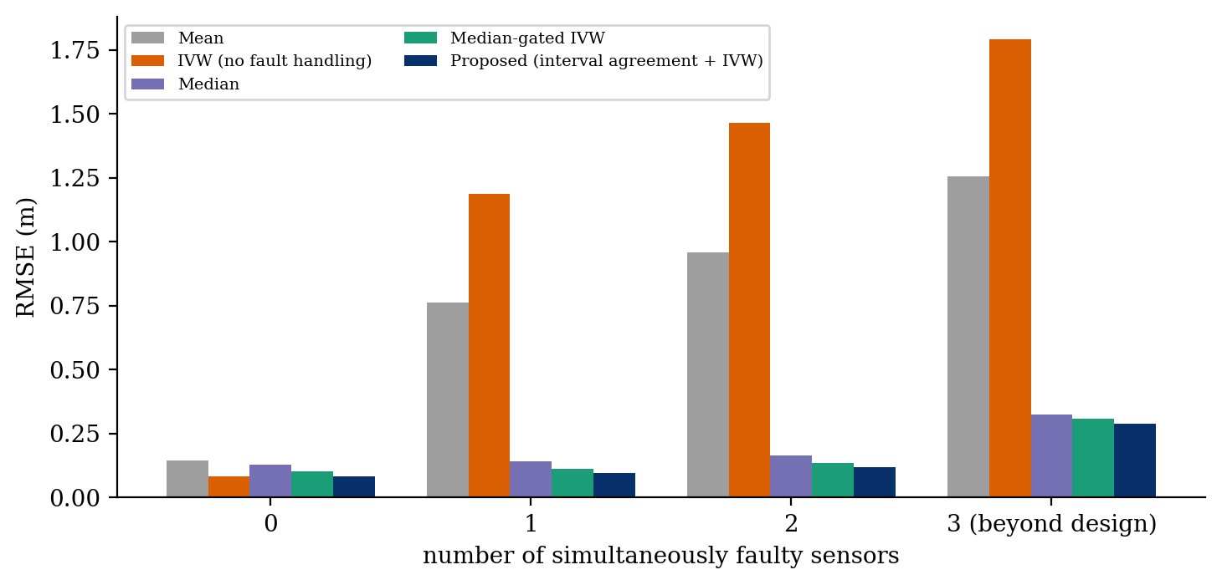
Figure 5. RMSE of the five fusion methods against the number of faulty sensors.
The next table gives the percentage of steps with an absolute error above 1.0 m.
Method | 0 faulty | 1 faulty | 2 faulty | 3 faulty
Simple mean | 0.000 | 9.101 | 14.430 | 20.947
Weighted mean (IVW) | 0.000 | 5.500 | 11.102 | 15.799
Median | 0.000 | 0.000 | 0.062 | 0.889
Median-gated IVW | 0.000 | 0.002 | 0.084 | 0.889
Proposed method | 0.000 | 0.004 | 0.058 | 0.631

The worst error found in any run, in metres, is shown below.
Method | 0 faulty | 1 faulty | 2 faulty | 3 faulty
Simple mean | 0.65 | 4.67 | 6.86 | 9.73
Weighted mean (IVW) | 0.37 | 14.07 | 14.93 | 14.71
Median | 0.70 | 0.95 | 1.75 | 14.40
Median-gated IVW | 0.81 | 1.23 | 1.99 | 14.41
Proposed method | 0.50 | 1.18 | 1.96 | 14.41

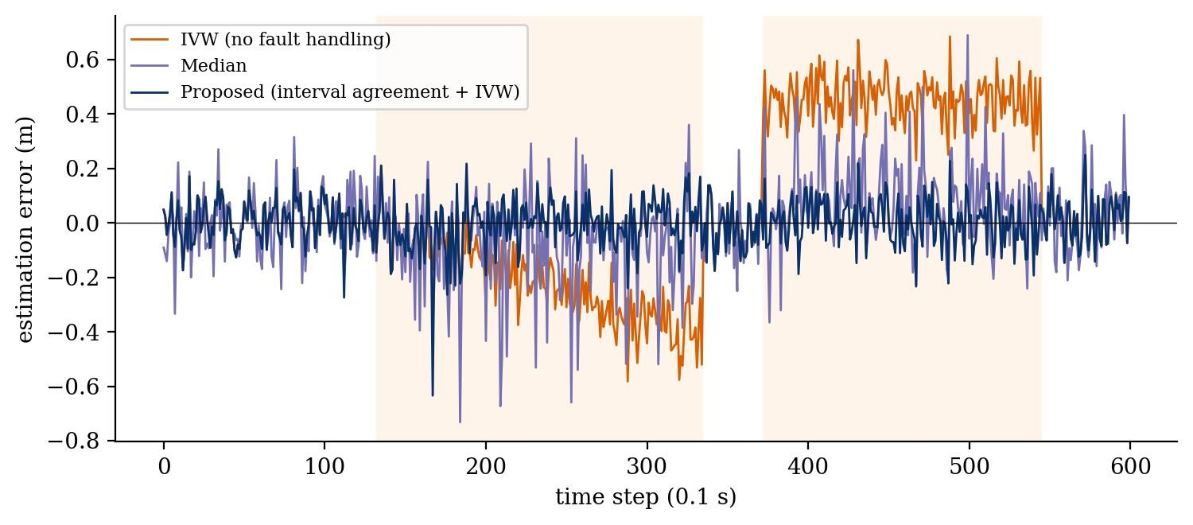
Figure 6. Estimation error over time in one illustrative run. Radar-1 drifts between steps 132 and 335, and Radar-2 has an offset between steps 372 and 545.

F. Fault Detection Results
Only the median-gated method and the proposed method produce flags. The table gives pooled precision, recall and false-alarm rate. A dash means the quantity is undefined because there was nothing to detect or nothing was flagged. A false-alarm rate shown as 0.000 means below 0.0005.
Faulty sensors | Method | Precision | Recall | False-alarm rate
0 | Median-gated IVW | – | – | 0.014
0 | Proposed method | – | – | 0.000
1 | Median-gated IVW | 0.754 | 0.772 | 0.017
1 | Proposed method | 0.992 | 0.727 | 0.000
2 | Median-gated IVW | 0.838 | 0.751 | 0.021
2 | Proposed method | 0.991 | 0.704 | 0.001
3 | Median-gated IVW | 0.854 | 0.696 | 0.028
3 | Proposed method | 0.979 | 0.647 | 0.003

G. Results by Fault Type
To see which faults are easy and which are hard, one sensor was made faulty in each run and the fault type was fixed for the whole batch of 100 runs. The table gives the RMSE.
Method | Stuck | Offset | Drift | Burst | Spike
Simple mean | 1.225 | 0.440 | 0.325 | 0.399 | 0.672
Weighted mean (IVW) | 1.731 | 0.655 | 0.409 | 0.204 | 0.992
Median | 0.144 | 0.145 | 0.142 | 0.140 | 0.133
Median-gated IVW | 0.114 | 0.114 | 0.115 | 0.116 | 0.106
Proposed method | 0.090 | 0.088 | 0.096 | 0.105 | 0.083

Fault type | Proposed precision | Proposed recall | Gated precision | Gated recall
Stuck | 0.994 | 0.881 | 0.780 | 0.904
Offset | 0.997 | 0.991 | 0.794 | 0.996
Drift | 0.987 | 0.699 | 0.741 | 0.762
Burst | 0.983 | 0.633 | 0.739 | 0.728
Fault type | Proposed precision | Proposed recall | Gated precision | Gated recall
Spike | 0.990 | 0.300 | 0.590 | 0.310

The recall for the spike fault is low for both methods because a spike is present on only about 30 % of the steps inside its window, whereas the evaluation labels the whole window as faulty. The sensor is healthylooking at the remaining steps, so these are not true misses in the sense of a wrong estimate being produced. The recall for drift is lower than for offset since the first part of a drift is smaller than the sensor’s own interval.

H. Effect of the Interval Factor k
The proposed method was run with k = 1, 2, 3 and 4 on a pooled set of 180 runs (60 each with zero, one and two faulty sensors). “False flags” counts healthy sensor-steps flagged as faulty and “missed” counts faulty sensor-steps that were not flagged.
k | RMSE (m) | False flags | Missed fault-steps | Steps with error > 1 m (%)
1.0 | 0.145 | 85,430 | 6,238 | 0.022
2.0 | 0.098 | 6,185 | 8,627 | 0.013
3.0 | 0.097 | 223 | 10,395 | 0.006
4.0 | 0.106 | 91 | 12,195 | 0.032

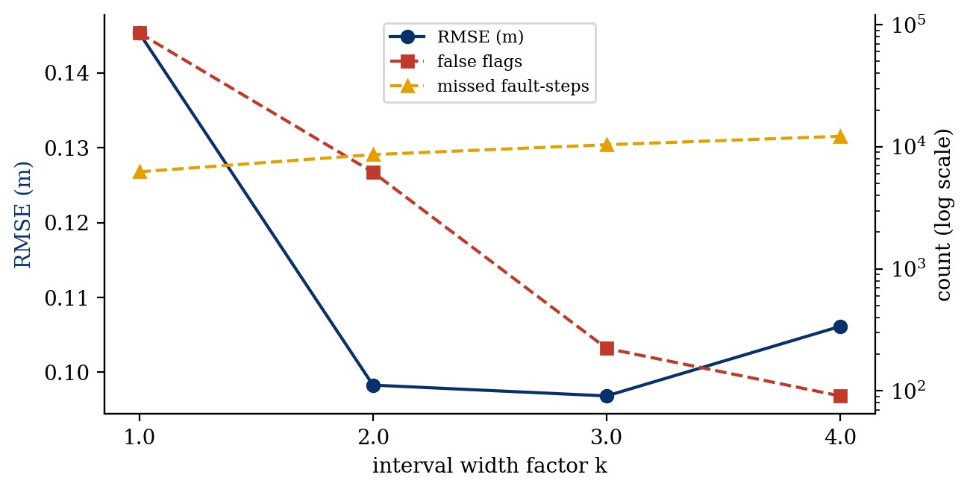
Figure 7. Effect of the interval width factor k on RMSE, false flags and missed fault-steps.

I. Run Time
The proposed routine, the weighted mean and the median were timed as plain Python functions called on random readings for growing n, taking the average over repeated calls. The fault bound was set to n/4 in each case. Times are in milliseconds per call.
n | Weighted mean | Median | Proposed
5 | 0.0046 | 0.0096 | 0.0287
10 | 0.0049 | 0.0097 | 0.0323
50 | 0.0045 | 0.0097 | 0.0720
100 | 0.0047 | 0.0095 | 0.1244
500 | 0.0052 | 0.0102 | 0.6226
1,000 | 0.0063 | 0.0174 | 1.5423
5,000 | 0.0141 | 0.0796 | 10.2559
n | Weighted mean | Median | Proposed
10,000 | 0.0232 | 0.1408 | 19.9901
50,000 | 0.1140 | 0.6696 | 116.4974

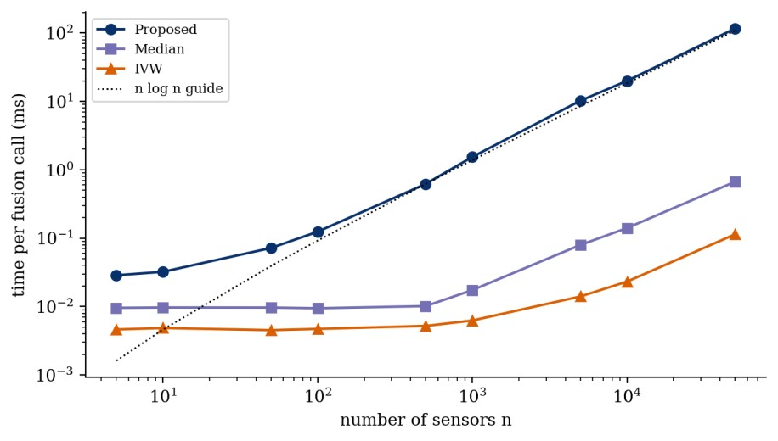
Figure 8. Time per fusion call against the number of sensors, on logarithmic axes.
At n = 5 the proposed routine needs about 0.029 ms per call, a negligible part of a 100 ms sensing cycle. From n = 1,000 to n = 10,000 its time grows by a factor of 13.0, close to the factor of about 13.3 expected from n log n scaling. The implementation is slower than the median by a large constant, mostly because the sweep is written in interpreted Python while the median uses compiled NumPy code. A C or C++ version would be much faster; the numbers here show the growth rate rather than achievable embedded timings.

J. Observations
- When no sensor is faulty, the proposed method matches the weighted mean (RMSE 0.081 m) and is better than the median and the simple mean, so the fault protection costs nothing in accuracy on healthy data.
- With one faulty sensor the weighted mean is the worst performer (RMSE 1.187 m), followed by the simple mean (0.761 m), while the proposed method reaches 0.095 m, against 0.141 m for the median and 0.113 m for the gated baseline.
- With two faulty sensors, the design limit for five sensors, the ordering is the same: 0.118 m for the proposed method, 0.134 m for the gated baseline and 0.164 m for the median.
- With three faulty sensors every method degrades, and the median, the gated baseline and the proposed method all reach a worst-case error of about 14.4 m. The proposed method still has the lowest RMSE (0.287 m) but this is no longer a guaranteed regime.
- The proposed method flags faulty sensors with precision above 0.97 in every configuration, whereas the gated baseline has precision between 0.75 and 0.85 and false-alarms on 1–3 % of healthy readings.
- Recall is only about 0.65 to 0.73 for the proposed method. The faults that go unflagged are mostly the early part of drifts and the quiet stretches of spike faults, which cannot be told apart from healthy noise.
- The differences between the proposed method and the best baselines are modest in absolute terms, a few centimetres of RMSE. The large gains are over the mean and the weighted mean.

VII. Results and Discussion

A. Reading the Results
The simple mean and the weighted mean fail in the way expected of non-robust estimators: one bad sensor is enough to raise the RMSE from about 0.1 m to between 0.8 m and 1.2 m. In RMSE terms the weighted mean is worse than the simple mean once a fault is present, since it leans on the precise sensors, and when a precise sensor is the faulty one the damage is greater. It is therefore not safe to reason that a more accurate fusion formula is also a safer one.
The median is a stronger competitor than might be expected. With five sensors and at most two faults, the median always lies between two healthy readings, so large errors cannot get through. What it gives up is accuracy: it treats a lidar and a camera as equals. The proposed method keeps the robustness of the median at low fault counts and recovers most of the accuracy of the weighted mean, which explains the difference of roughly 0.05 m between them in the one-fault case.
The gated baseline loses accuracy even without faults (RMSE 0.101 m against 0.081 m). A plausible explanation is that the median is itself a noisy reference, so a very precise sensor such as the lidar, whose gate is only 0.3 m wide, is sometimes rejected although it is healthy. This was not tested separately. The interval-agreement test does not have this weakness because it compares sensors with each other through their stated uncertainties, not with one noisy reference.

B. Why a Classical, Interpretable Method
Every flag produced by the method can be explained by looking at the intervals: this sensor was left out because its interval does not touch the region where four other intervals overlap. Proposition 2 gives a worstcase statement that holds whatever the size of the fault. A trained model would probably perform well on the cases it has seen, but arguing about the cases it has not seen is much harder, and that is the argument that matters for a safety function.

C. Limitations
- The study is one-dimensional and uses one scalar per sensor. Real fusion handles vectors, covariances and object tracks.
- The method assumes known and correct noise levels. If a σ_{i} is too small, a healthy sensor will be flagged; if it is too large, a faulty one will pass.
- Healthy noise is assumed independent. Two cameras that look through the same windscreen, or two radars in the same rain, may fail together, so the real number of independent faults can exceed what a count of sensors suggests.
- The fault bound f must be chosen in advance. If more than f sensors are faulty, the guarantee in Proposition 1 does not apply, and the experiment with three faulty sensors shows the consequences.
- The tie-break between equally good regions is heuristic.
- The effectiveness of the degraded flag in warning about excess faults was not measured separately in this study.
- The experiments are simulated. The fault types are plausible but they are the author’s choices, not recorded failures from a vehicle.
- Timing was measured in Python and says nothing about embedded hardware.

D. Sensitivity to the Interval Factor
The k study shows the expected trade-off. A narrow interval (k = 1) makes healthy sensors miss the agreement region by chance, which produces 85,430 false flags and a higher RMSE. A wide interval (k = 4) gives few false flags but lets small faults hide, and the number of missed fault-steps rises from 10,395 at k = 3 to 12,195. The value k = 3 gave the lowest RMSE, though only slightly below k = 2, and few false flags on this data, which is a convenient default but should be treated as a tuning parameter for any real sensor set.

E. Common-Mode Faults and Degraded Operation
When the agreement count falls below n − f, the algorithm still returns a number but marks it degraded. What a vehicle should do in that situation is a system-level decision outside this report: reduce speed, increase the following distance, request driver takeover or switch to a minimal-risk manoeuvre. The point of the marker is that the downstream software is told when the fusion layer can no longer vouch for its own output.

VIII. Conclusion
This report examined how redundant sensor readings in an autonomous vehicle can be combined so that a bounded number of faulty sensors does not spoil the result. The problem was posed as an algorithm-design task, and a fusion routine was developed that builds confidence intervals, finds their region of greatest overlap with a sort-and-sweep pass, removes sensors outside it, and averages the rest with inverse-variance weights. Its cost is O(n log n) time and O(n) space per cycle. Two propositions describe what it guarantees: the truth lies in a region of count at least n − f when at most f sensors are faulty, and an undetected faulty sensor can deviate from the truth only by a few multiples of the sensor noise.
In a simulation with five sensors and five fault types, the method matched the weighted mean when all sensors were healthy and gave the lowest RMSE when one or two sensors were faulty, with flag precision above 0.97. The margin over the median and a median-gated baseline is small in absolute terms, and the method does not rescue the estimate once a majority of the sensors is faulty. The results are simulated and the conclusions are limited to the scalar, synchronised, independent-noise setting that was studied.

IX. Future Work
- Embed the agreement test in a Kalman filter or another tracker so that temporal information supports detection, in particular for slow drifts.
- Extend interval agreement from a scalar to boxes or ellipsoids for multi-dimensional states.
- Persist flags over several steps so that a sensor is not re-admitted the moment its reading briefly falls back into range.
- Estimate the noise levels σ_{i} online and study the effect of wrong values.
- Inject faults into recorded multi-sensor driving data instead of simulated signals, and test with correlated failures.
- Measure the degraded flag as a detector of excess faults and compare against the Brooks–Iyengar hybrid [9].
- Implement the routine in C or C++ and measure the timing on automotive-grade hardware.

X. Final Research Perspective
The main point to take from this work is that robustness and accuracy do not have to be traded against each other when the uncertainty of each sensor is available. The interval test provides the robustness, and the weighting provides the accuracy. The method is simple enough to be checked by hand, and the cost of that simplicity, namely independent noise, a fixed fault bound and a single scalar, is stated openly so that later work can relax it.

Appendix A. Symbols and Notation
Symbol | Meaning
n | Number of redundant sensors
f | Largest number of faulty sensors the design must tolerate (f < n/2)
x | True value of the measured quantity
z_{i} | Reading of sensor i
σ_{i} | Standard deviation of the noise of sensor i
w_{i} | Inverse-variance weight, 1/σ_{i}²
k | Interval width factor
I_{i} | Interval [z_{i} − kσ_{i}, z_{i} + kσ_{i}]
c(y) | Number of intervals containing the point y
c* | Maximum of c(y)
R = [lo, hi] | Selected agreement region
S | Set of sensors whose intervals touch R
x ̂ | Fused estimate

Appendix B. Python Implementation
The function below implements the proposed method. Running the file on the worked example of Section V-C returns an estimate of 40.080 m with Camera-2 (index 3) flagged and the degraded marker false.
import numpy as np

def fuse(z, sigma, f, k=3.0):
"""Interval-agreement fault-tolerant fusion of n redundant readings. Returns (estimate, flagged_sensor_indices, degraded).""" z = np.asarray(z, float); sigma = np.asarray(sigma, float) n = len(z)
# 1. build and sort interval end-points (START sorts before END on ties) events = [] for i in range(n):
events.append((z[i] - k * sigma[i], 0, i)) events.append((z[i] + k * sigma[i], 1, i)) events.sort()
# 2. sweep: count how many intervals cover each stretch count, segments = 0, [] for j in range(2 * n - 1):
count += 1 if events[j][1] == 0 else -1 segments.append((count, events[j][0], events[j + 1][0])) best = max(s[0] for s in segments) med = float(np.median(z))
# 3. among the best segments take the one closest to the median lo, hi = min((s for s in segments if s[0] == best), key=lambda s: abs(0.5 * (s[1] + s[2]) - med))[1:] degraded = best < n - f
# 4. keep sensors whose interval touches the agreement region ok = (z + k * sigma >= lo) & (z - k * sigma <= hi) w = 1.0 / sigma[ok] ** 2 estimate = float(np.sum(w * z[ok]) / np.sum(w)) return estimate, np.where(~ok)[0].tolist(), degraded

if __name__ == "__main__": sigma = [0.10, 0.25, 0.50, 0.40, 0.20] z = [40.05, 40.30, 39.70, 43.60, 40.12] print(fuse(z, sigma, f=2))

Appendix C. Evaluation Formulas

RMSE = sqrt( (1/N) Σ (x̂_{t} − x_{t})² ) Precision = TP / (TP + FP) Recall = TP / (TP + FN) False-alarm rate = FP / (number of healthy sensor-steps)
Here TP counts faulty sensor-steps that were flagged, FP counts healthy sensor-steps that were flagged, and FN counts faulty sensor-steps that were not flagged. A sensor is labelled faulty for the whole of its fault window.

Appendix D. Reproducibility Checklist
- Use the sensor noise levels 0.10, 0.25, 0.50, 0.40 and 0.20 m and the signal x(t) = 40 + 10 sin(2πt/300) + 0.01t.
- Use 600 steps per run; fault windows of 120 to 259 steps that start no earlier than step 50 and end at least 10 steps before the end of the run.
- Use NumPy default_rng with seed 2026 for the main comparison (150 runs each for 0, 1, 2 and 3 faulty sensors), seed 77 for the fault-type study (100 runs per type), seed 5 for the k study (60 runs for each of 0, 1 and 2 faulty sensors) and seed 9 for the run-time test.
- Feed the same readings to all five methods in every run.
- Set f = 2 and k = 3 for the main experiments; the gated baseline uses the same k.
- Report the unsafe-estimate threshold (1.0 m) together with the results.
- Report that all data are synthetic and that timing was measured in Python on one machine.

References
- D. L. Hall and J. Llinas, “An introduction to multisensor data fusion,” Proceedings of the IEEE, vol. 85, no. 1, pp. 6–23, 1997.
- B. Khaleghi, A. Khamis, F. O. Karray, and S. N. Razavi, “Multisensor data fusion: A review of the state-of-theart,” Information Fusion, vol. 14, no. 1, pp. 28–44, 2013.
- A. Avižienis, J.-C. Laprie, B. Randell, and C. Landwehr, “Basic concepts and taxonomy of dependable and secure computing,” IEEE Transactions on Dependable and Secure Computing, vol. 1, no. 1, pp. 11–33, 2004.
- R. Isermann, “Model-based fault-detection and diagnosis – status and applications,” Annual Reviews in Control, vol. 29, no. 1, pp. 71–85, 2005.
- R. E. Kalman, “A new approach to linear filtering and prediction problems,” Journal of Basic Engineering, vol. 82, no. 1, pp. 35–45, 1960.
- Y. Bar-Shalom, X. R. Li, and T. Kirubarajan, Estimation with Applications to Tracking and Navigation. New York, NY, USA: Wiley, 2001.
- L. Lamport, R. Shostak, and M. Pease, “The Byzantine generals problem,” ACM Transactions on Programming Languages and Systems, vol. 4, no. 3, pp. 382–401, 1982.
- K. Marzullo, “Tolerating failures of continuous-valued sensors,” ACM Transactions on Computer Systems, vol. 8, no. 4, pp. 284–304, 1990.
- R. R. Brooks and S. S. Iyengar, “Robust distributed computing and sensing algorithm,” Computer, vol. 29, no. 6, pp. 53–60, 1996.
- J. Van Brummelen, M. O’Brien, D. Gruyer, and H. Najjaran, “Autonomous vehicle perception: The technology of today and tomorrow,” Transportation Research Part C: Emerging Technologies, vol. 89, pp. 384–406, 2018.
- T. H. Cormen, C. E. Leiserson, R. L. Rivest, and C. Stein, Introduction to Algorithms, 4th ed. Cambridge, MA, USA: MIT Press, 2022.
- International Organization for Standardization, ISO 26262:2018, Road vehicles – Functional safety, 2018.

